Valdosta State University

Youth Protection Continuity Guide

Table of Contents
Introduction……………………………………………………………………………….3
UGS Board Policy 6.9 Programs Serving Minors………………………….4
VSU Policy Programs Serving Minors………………………………………...5
MOC Flow Chart…………………………………………………………………………12
Registration Procedure for VSU Sponsored Youth Programs………13
Registration Procedure for Third Parties…………………………………….17
VSU Private Lesson Policy………………………………………………………….19
VSU GA Dept. of Early Care and Learn Exemption …………………….21
VSU Accident/Incident Report Form………………………………………….27
VSU Mandatory Reporting Policy……………………………………………….28
Youth Protection Ratio………………………………………………………………30
Youth Protection Registry link and IT Contact…………………………….31
Policy Exemptions………………………………………………………………………32
Training PowerPoint…………………………………………………………………..33

Intro
Valdosta State University (VSU) established a youth protection policy shortly after the University System of Georgia released a system level policy on Programs serving Minors. The policy is designed to create a safe environment for minor programs sponsored by the university and third party programs taking place on university property. The policy’s shepherd and advocate is the Youth Protection Coordinator. VSU’s policy is divided into a two prong approach: procedural and substantive.
The procedural portion is ensuring that all programs understand the three requirements for authorized adults working or volunteering with youth protection programs and how to ensure completion and tracking of the requirements on the Youth Protection Registry. These three requirements are background check, training and code of conduct. Also under the procedural portion, the program administrators must be trained on how to track and ensure completion of minor participant forms on the Youth Protection Registry. The procedural part of the policy is achieved by monthly training sessions and one on one meetings with the program administrator.
The substantive portion of the policy is where the rubber meets the road. The ultimate goal of the policy is to ensure the safety of the minors being served by VSU. Although the procedural requirement is a must for documentation and covering industry standards, substantive part is what ensures proper training of program administrators and authorized adults to obtain and maintain a safe environment for minors. Substantive part of the policy is achieved by monthly training sessions of program administrative on areas of youth protection focusing on prevention rather than reaction. These monthly trainings should touch on program preparation, worker/volunteer training focusing on interaction with minors and incident prevention and program structural organization. The Youth Protection Coordinator should also provide training to program workers/volunteers at the beginning of each program and provide refresher and new training if the program is year around. The coordinator should be on hand to help guide programs in their development of youth protection and make sight visits to help with safety.
The Youth Protection Coordinator also helps the Institutional Research Board as the minor advocate and plays a role in developing safety procedures.
*Please note that Youth Protection was first named Minors on Campus (MOC) and maybe referred to as such in this document.

6.9 Programs Serving Minors

University System of Georgia (USG) institutions periodically conduct, sponsor, or host programs designed to serve minors who are not enrolled as students, including but not limited to camps, clinics, after school programs, and activities. Employees and volunteers associated with these programs who are reasonably anticipated to have direct contact or interaction with minor program participants must be appropriately pre-screened and trained. Institution presidents shall establish institution-level procedures to implement this policy and related directives from the USG.

Website: https://www.usg.edu/organizational_effectiveness/programs_serving_minors

VALDOSTA STATE UNIVERSITY
POLICY FOR PROGRAMS AND ACTIVITIES SERVING MINORS
The Valdosta State University is committed to providing a safe and healthy environment for all who participate in programs and activities on campus or otherwise affiliated with the University. There are a variety of opportunities available for minor children, including academic camp, athletic camps, clinics, conducting or viewing research, after-school programs, work or activities under supervision of an individual faculty member, enrichment classes, and other activities. This Policy recognizes the special duty of care and supervision when working with minors and sets forth operational requirements to enhance the protection of minors.
I. Definitions
Mandatory Reporter: Any person who is required by Georgia law (O.C.G.A. §19-7-5) to report suspected child abuse to the appropriate authorities. Mandatory Reporters include but are not limited to faculty/teachers, administrators, counselors, social workers, psychologists, law enforcement personnel, and other persons who participate in providing care, treatment, education, training, supervision, coaching, counseling, recreational programs, or shelter to Minors.
Minor: Any person under 18 years of age (O.C.G.A §39-1-1).
Program/Activity/Camp: Any academic, admissions, athletic, educational, service, leadership, or recreational program serving one or more Minors, including, but not limited to camps, clinics, conferences, workshops, tutoring, mentoring, group lessons, seminars, competitions, internships or experiential learning, conducting or viewing research, pre-enrollment visits, after-school programs, or other enrichment opportunities.
Program/Activity/Camp Administrator: Any individual who has primary and direct operational responsibility for the overall content and execution of a Program/Activity and who serves as the primary point of contact.
Program/Activity/Camp Staff: Individuals, whether paid, volunteer, or for academic credit, who have care, custody, control, and/or direct contact or interaction with Minors involved in Program/Activities/Camps. This includes, but is not limited to, University administrators, faculty, staff, students, volunteers, and third parties when operating a Program/Activity.
Third Party: An individual, organization, or entity external to the University, to which the University allows use of its facilities to operate a Program/Activity.
Sponsoring Unit: Any department or unit of the University that offers a Program/Activity.
University Facility: A building, structure, classroom, research or teaching laboratory, outdoor area, grounds, or athletic venue owned, leased, or controlled by the University, or used in connection with any Program/Activity.
II. Applicability
This Policy applies broadly to all Programs/Activities/Camps serving one or more Minors, including those:
- Offered by departments or units of the University at a University Facility or sponsored by the University at other locations;
- Offered by the University’s student organizations at a University Facility or sponsored by University student organizations at other locations; or
- Offered by Third Parties utilizing a University Facility.

This Policy does not apply to:
- Programs/Activities/Camps for Minors enrolled in undergraduate or graduate academic coursework;
- Events or visits to campus where Minors are supervised by their parent/guardian/school;
- Events at the University that are open to the general public or invited guests where parents/guardians/school are expected to provide supervision of Minors;
- IRB-supervised research;
- Minor employees; and
- Valdosta State University employees or students hosting family members, friends, or other guests
This Policy shall supplement, not replace, any existing safety and security measures, policies, or codes of conduct currently in place or hereinafter enacted.
III. Requirements
This Policy provides minimum operational requirements for Programs/Activities/Camps involving Minors. Recognizing that all Programs/Activities/Camps are unique as to subject matter and risk, each Program/Activity Administrator, Sponsoring Unit, or Third Party must evaluate the nature of the Program/Activity and take appropriate actions to ensure the safety and security of all individuals involved and to ensure compliance with all applicable laws, regulations, and policies.
- Review and Approval
The following considerations should be addressed by the Program/Activity Administrator in advance of the Program/Activity:
- Alignment of the Program/Activity with the University’s mission;
- Appropriate subject matter and fully planned activity itinerary;
- Appropriate staffing and supervision ratios, with special regard to avoiding one-on-one contact between Minors and Program/Activity Staff;
- Program/Activity Staff Code of Conduct and guidelines;
- Appropriate training for Program/Activity Staff;
- Minor Code of Conduct, Applicable Forms, Waivers, and any supplemental Program/Activity guidelines;
- Program/Activity orientation and information for Minors and parents;
- Transportation arrangements;
- Housing arrangements with special consideration for overnight Programs/Activities/Camps;
- Contracts for Auxiliary Services and Food Services;
- Safety and security planning including, but not limited to:
  - Basic first aid;
  - Emergency response and notification plans;
  - Reporting protocols for injury and/or illness; and
  - Inclement weather plans;
- Response protocols for accusations of misconduct;
- Insurance;
- Any licensing or exemption required by a government agency; and
- Record retention policies

- Program/Activity Registration and Renewal

Program Administrators must complete the following steps to in order to register their Programs/Activities/Camp.

1. Complete the online Minors on Campus Form for approval by the Minors on Campus Coordinator: https://www.valdosta.edu/administration/social-equity/minors-on-campus/minors-on-campus-form.php;
2. University sponsored Programs/Activities/Camps that are approved will be added to the Minors on Campus Registry.
3. Third Party Programs/Activities/Camps approved will be required to submit a Third Party Facilities Use Agreement and insurance certificate;
4. All Programs/Activities/Camps, University Sponsored or Third Party, must register annually.

- Background Investigation and Screening
All University Program/Activity Staff who have direct contact with minors are required to undergo a criminal background check to include, but not limited to, each state the individual resided and federal criminal history check covering a minimum of seven (7) years, national sex offender search and social security number check. Criminal background checks for VSU employees and volunteers with direct contact with non-student minors must have been run and cleared by the VSU Office of Human Resources within the past twelve (12) months before initial direct contact with non-student minors and every four (4) years afterward. Offenses dealing with domestic abuse, drugs, violence, crimes against the elderly, infirm, etc. must be assessed carefully. The youth program will be charged the vendor fee for the criminal background check. Program/Activity Administrators must be in receipt of background check clearance on all Program/Activity Staff prior to involvement.
Program/Activity Staff must self-report any arrest, charge, or criminal conviction occurring after the date of the background check to their Program/Activity Administrator, prior to returning to a Program/Activity. Additionally, all University employees are subject to University System of Georgia Human Resources Administrative Practice Manual’s mandatory reporting of charges or conviction of a crime other than a minor traffic offense. Depending on the nature of the Program/Activity, additional screening of Program/Activity staff beyond background checks may be advisable, including in-person interview and/or reference checks.
Personnel in charge of screening volunteers should be aware of the inherent limitations of background checks and should seek to utilize other screening methods, when possible, in addition to background checks to include in-person interviews and reference checks.
- Training
All Program/Activity Staff must be trained on their responsibilities or issues related to Minor health, safety, and security. This training is provided through VSU and via Everfi training website. The training must be complete within the past twelve (12) months before initial direct contact with a minor and then every two years afterward. Training documentation and certifications should be maintained by the Program/Activity Administrator.
All Program/Activity Staff must receive training on the following:
- Mandatory Reporting obligations, including child abuse awareness and prevention;
Additionally, training appropriate to the specific Program/Activity as developed by the Program/Activity Administrator must be also provided on the following:
- Code of Conduct for Program/Activity Staff and Minor participants;
- Reporting requirements during the Program/Activity, processes, and contacts;
- Disability accommodations and review and evaluation of special requests;
- Safety and security protocols;
- First aid guidelines and medication management; and
- Activities, risks, and responsibilities of the Program/Activity, as applicable.

- Records Retention
All records should be retained in accordance with Board of Regents policies on record retention. Copies of all required forms and documentation pertaining to Minors should be retained for a period of three (3) years after the Minor reaches the age of eighteen (18). Records pertaining to Program/Activity Staff should be retained for five (5) years.
F. Code of Conduct
The University requires the highest standards of conduct when interacting with
Minors, including compliance with all applicable laws, regulations, and policies.
1. Code of Conduct: All Minor participants and Program/Activity Staff must agree to abide by the applicable Code of Conduct as well as any supplemental Program/Activity guidelines developed by the Program/Activity Administrator.

2. Requirements for Minor participants: Parents/guardians must submit required forms before Minors will be allowed to participate in Programs/Activities/Camps. These forms may include, but are not limited to, a participation agreement form, authorization to administer medication, pick-up authorization, medical information and authorization, release of claims/waiver of liability, media/photo/video release, and Minor Participant’s Code of Conduct.

IV. Third Party Use of a University Facility
In order to utilize University Facilities for Programs/Activities/Camps, Third Parties must execute a Facilities Use Agreement. Use for Program/Activity requires compliance with this Policy, including certifying criminal background checks and ensuring proper training for all Program/Activity Staff, and must demonstrate that they have minimum insurance requirements:
Coverage Limits
Each Occurrence Limit $1,000,000
Damage to Premises Rented To You $300,000 Any one premises
Personal & Advertising Injury $1,000,000 Any one person/organization
Abuse or Molestation $1,000,000 Any one person
General Aggregate Limit $2,000,000 Products/Completed Ops. Aggregate Limit $2,000,000
V. Reporting
- Injury: In order to maintain a safe environment for all students, faculty, staff, and visitors, it is important the university be informed, at the earliest possible date, of any injuries that occur at a University Facility or to faculty and staff in the course of their work responsibilities.

- Child Abuse/Mandatory Reporters: Any Program/Activity Staff or other Mandatory Reporter who has reasonable cause to believe that suspected child abuse has occurred, shall immediately report the suspected abuse to the Valdosta State University Police Department and the appropriate supervisor or Program/Activity Administrator who shall take immediate action. All University employees must appropriately report suspected child abuse. Do not attempt to investigate a matter further or gather additional information before reporting.

If you suspect child abuse, or simply have an idea or uneasy feeling about a possible abuse situation, immediately report the situation to ALL of the following:

- The Valdosta State University Police Department 229-259-5555 or 911 (emergency);
- The Program/Activity Administrator; AND
- The Georgia Division of Family and Children Services at 1-855-GACHILD

A Mandatory Reporter must ensure that the Division of Family and Children Services is notified of the suspected abused immediately and in no case later than 24 hours after the Program/Activity Staff (or other reporter) first had reasonable cause to suspect the abuse.
By doing so, you are not necessarily making an accusation; you are merely reporting facts for trained professionals to evaluate and investigate.
VI. Accountability
- Violations and Sanctions: Violators of this Policy will be held accountable for their actions under the Program/Activity’s Code of Conduct, University policy, and applicable law. Sanctions for violations may include, but are not limited to, suspension of University funding, non-renewal or termination of the Program/Activity, suspension, dismissal, or termination of University employment or Program/Activity Staff status, or removal or barring from University Facilities.

- University Funding: University Programs/Activities/Camps that are not approved and registered pursuant to this Policy will not be eligible for payment, repayment, or reimbursement by Valdosta State University Financial Services.
VII. Policy Implementation
This Policy is adopted in accordance with Board of Regents Policy 6.9, Programs Serving Minors.
VIII. Policy Responsibility
Because the protection Minors is a University-wide concern, a key group of administrators will be charged by the President to serve on a committee to review and address issues arising under this Policy. The committee will consist of four to six administrators selected from the following units: Academic Affairs, Athletics, Human resources, Legal Affairs, and Student Affairs.
The committee is empowered to take steps necessary to promote the safety of Minors while at the University and for University Programs/Activities/Camps held elsewhere, including:
- Recommending changes to this Policy;
- Recommending appropriate actions for Program/Activity Administrators, Departments, and Units in accordance with applicable University policies and procedures;
- Creating, updating, or modifying forms and resources available for Programs/Activities/Camps serving Minors;
- Auditing Programs/Activities/Camps for compliance with this Policy;
- Initiating enforcement actions against an individual or Program/Activity; and
- Any other action reasonable required in furtherance of this Policy

IX. Forms and Resources
Sample Forms, Program/Activity Checklists, and additional resources are available at
https://www.valdosta.edu/administration/social-equity/minors-on-campus/.

Policy History

Adopted by University Cabinet

Resources

University System of Georgia Board Policy 6.9 Programs Serving Minors: https://www.usg.edu/organizational_effectiveness/programs_serving_minors

University System of Georgia Human Resources Administrative Practice Manual: https://www.usg.edu/hr/manual

University System of Georgia Board of Regents Policy Manual:
https://www.usg.edu/policymanual/

Board of Regents Records Retention Policy:
http://www.usg.edu/records_management/schedules/

State of Georgia Mandatory Reporter Law- O.C.G.A. §19-7-5 (2016):
https://www.usg.edu/assets/organizational_effectiveness/documents/mandated_reporter_law2016.pdf

Valdosta State University Public Safety Policy:
https://www.valdosta.edu/administration/finance-admin/human-resources/policy/public-safety.php

Valdosta State University Human Resources and Employee Development:
https://www.valdosta.edu/administration/finance-admin/human-resources/

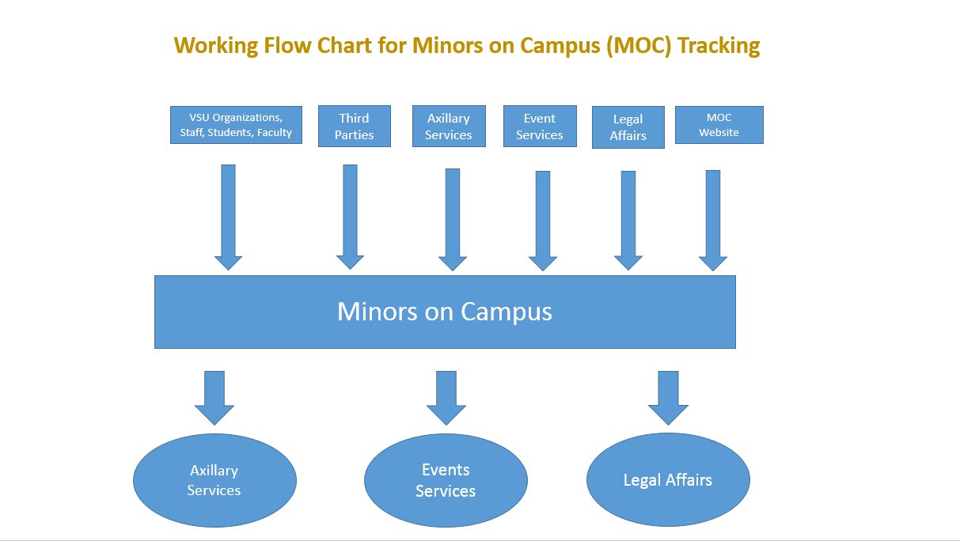

Registration Procedure for Valdosta State University sponsored Youth Programs
Once a Program Administrator has completed the Youth Protection request form and been approved to sponsor a youth program, he or she will be added to Youth Protection Registry: https://apx.valdosta.edu/apex/f?p=158:LOGIN_DESKTOP:4628633155532. Please log on using your university email/password and add your program(s). Once your program(s) is added, you can input or bulk upload both the authorized adults and minor participants into the registry. I have attached the excel forms for bulk uploading.
REGISTRY CERTIFICATION:
As the Program Administrator, you will be responsible for certifying completion of training, code of conduct and background checks for authorized adults and participant authorization packets for minors. Certification is done by providing the dates of completion for training, code of conduct and background checks for authorized adults and participant authorization packets for minors in the Youth Protection Registry. Department Heads will be notified of non-compliance.
Certification of authorized adults: Thirty (30) days prior to the program/camp start date or the program/camp will not be approved.
Certification of minor participants: First day of program/camp or the program/camp will be removed from the approved list on the registry.
MOC Policy Requirements For Authorized Adults:
Requirement | Renewal Dates
MOC Training | Every two (2) years
Background Check | Every four (4) years
Code of Conduct | Annually (every year)
Training Requirements for Authorized Adults:
Authorized Adults affiliated with the University who are in direct contact with Minors must satisfactorily complete the online training module provided by the University through Lawroom/Everfi. The Program Administrator can request the training link for authorized adult(s) by using the attached form and sending the form via email to minorsoncampus@valdosta.edu. Please note, the email with the training link is titled Valdosta State University Youth Protection Online Training and will be sent directly to the authorized adult(s) from Lawroom/Everfi. Please make your staff aware that the email may be delivered to their junk/spam/other folders. Program Administrators are responsible for keeping track of training completion and certificates.
BACKGROUND CHECKS Authorized Adults:
1. Background checks are required to be complete on all authorized adults thirty (30) days prior to program/camp date. Standard cost per background check is $20.50; however, total cost is dependent on number of background checks completed, number of states and alias names based on applicant’s history. Please note that the background checks can take up to fourteen (14) business days if not longer.
Candidates for the background check have to ten-days from the time they receive an email notification from Accurate to complete their background check questionnaire. If the background check questionnaire is not completed within the ten-day time frame the background check will be canceled and not resubmitted.
2. Human Resources (HR) requires the following to be completed and submitted PRIOR to beginning the background check process (the form is three (3) pages and attached in this email):
a. Inter-Departmental Chargeback Form to include the following information:
i. Name and Dates of Program
ii. Program Administrator Name and Email Address iii. Account number to charge for cost of background checks iv. Budget Manager Name and Signature
b. List of names and email address requiring a background check
3. Once the three (3) page form is completed by the Program Administrator, the Program Administrator will email the request to minorsoncampus@valodsta.edu. HR will not complete the request if the paperwork is incomplete.
4. Once all completed paperwork has been received in HR, the Employment Analyst will email the link to complete the background check information to everyone on Background Check List.
5. The Employment Analyst will update the list with the date(s) the background check(s) is/are completed and notify the Program Administrator. If any background checks come back as not eligible, the Employment Analyst will notify both the Program Administrator and the Minors on Campus Program Coordinator.
CODE OF CONDUCT Authorized Adults:
Code of conduct must be signed annually by all authorized adults working or volunteering at program/camp.
RECORD RETENTION FOR CAMPS/PROGRAMS:
All records should be retained in accordance with Board of Regents policies on record retention. Copies of all required forms and documentation pertaining to Minors should be retained for a period of three (3) years after the Minor reaches the age of eighteen (18). Records pertaining to Program/Activity Staff should be retained for five (5) years. The retention schedule for all USG records can be accessed from the link: USG Records Retention Schedule
Forms:
All forms discussed above for both Authorized Adults and Participants are located on the Minors on Campus Website: https://www.valdosta.edu/administration/social-equity/minors-on-campus/forms-for-minors.php
All the above information can be found in detail on the Minors on Campus website: https://www.valdosta.edu/administration/social-equity/minors-on-campus/. If you have any questions or concerns, please contact the Minors on Campus Coordinator at 229-333-5643.

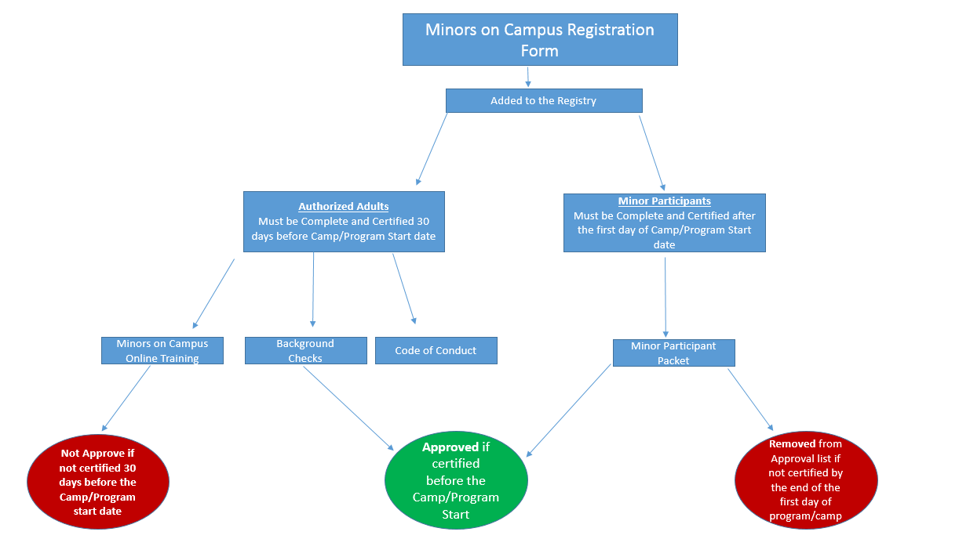
Registration Procedure for Third Parties
Third parties using VSU Facilities must present a Facilities Use Agreement/License Agreement to the Minors on Campus Coordinator thirty (30) days prior to the program/camp start date. The Agreement must contractually agree to comply with VSU’s policy requirements for background checks, training and code of conduct for all employees and/or volunteers and must provide proof that they have minimum insurance requirements for approval. Third Parties are responsible for coordinating and completing these requirements and must keep records of all requirements and minor participants open for review by Valdosta State University.
Minors on Campus Policy Requirements For AUTHORIZED ADULTS:
Requirement | Renewal Dates
MOC Training | Every two (2) years
Background Check | Every four (4) years
Code of Conduct | Annually (every year)
Third Party Background Investigation FOR AUTHORIZED ADULTS:
Valdosta State University’s Minors On Campus Coordinator conducts background checks on third parties. Third parties working with minors using VSU facilities must ensure all of their program/activity staff are background checked. Background investigations shall include, at a minimum, the following checks:
- A state and federal criminal history check covering a minimum of seven (7) years.
- A nationwide sex offender search.
- A social security number check using the Form I-9 and the federal E-Verify system.
- A credit check for positions that have access to financial resources such as handling money, checks, purchasing cards, etc.
INSURANCE COVERAGE REQUIREMENTS:
Coverage Limits
Each Occurrence Limit $1,000,000
Damage to Premises Rented To You $300,000 Any one premises
Personal & Advertising Injury $1,000,000 Any one person/organization
Abuse or Molestation $1,000,000 Any one person
General Aggregate Limit $2,000,000 Products/Completed Ops. Aggregate Limit $2,000,000
RECORD RETENTION:
Third Parties are required to keep records of both the authorized adults and minor participant paperwork. Child and Youth Participant Records must be kept for 3 years after the participant reaches the age of 18. These are records that document the participation of children and youth in programs sponsored by the institution. This series of records may include: applications, enrollment records, progress reports and assessments, immunization records, parental consent forms, activity records, and lists of attendees. Other records should be kept in accordance with the retention schedule for that document, i.e. individual volunteer files must be kept for 3 years after separation, daily logs must be kept 1 or 3 years depending upon the type of log, insurance records must be kept 7 years, leases must be kept for 7 years after the expiration of the agreement, etc. The retention schedule for all USG records can be accessed from the link: USG Records Retention Schedule

Valdosta State University Private Lesson Policy
Private Lessons on VSU Campus:
1. All Facility/Staff/Students teaching private lessons must register annually with the Minors on Campus Registry and meet all the requirements under VSU’s MOC policy.
2. All Facility/Staff/Students teaching private lessons must have all minors complete the Minor participant packet; this will also include a waiver which parents acknowledge that there is a one-one lesson taking place.
3. All Facility/Staff/Students teaching private lessons must maintain and provide to the Music Department a list of private lessons that includes the student’s name, date and time.
4. All lessons must be taught in a room with an unobstructed window.
5. The Minors on Campus Coordinator and Music Department Head must always have access to the lessons for observation purposes.
Private Lessons for Recruitment Purposes off Campus:
1. All Facility/Staff/Students teaching private lessons for recruitment purposes must register annually with the Minors on Campus Registry and meet all the requirements under VSU’s MOC policy.
2. All Facility/Staff/Students teaching private lessons for recruitment purposes must contact the school where the recruitment is taking place and obtain permission in writing for the visit and provide proof of permission to the Music department.
3. All Facility/Staff/Students teaching private lessons for recruitment purposes must contact the school in advance and request that the students’ parents be notified of the potential for one on one lessons and provide the below waiver:
Parent Waiver - Private Lessons
As the parent/guardian of _______________________________________ (name of student), a minor receiving individualized music instruction at Valdosta State University School of Music, I understand that my child may be in a room alone with an adult instructor.
The Valdosta State University has conducted background checks for all of its instructors, and diligently sought to minimize the instances of unsupervised contact in accordance with its policies. However, the nature of individualized music lessons is such that one-to-one sessions may be unavoidable.
By signing below, I hereby acknowledge my awareness and understanding that my child may be alone with an adult instructor, and give my consent.
______________________________________
Parent/guardian printed name
_______________________________________ __________
Parent/guardian signature Date
Name of teacher _________________________________________
4. All lessons must be taught in a room with an unobstructed window.
5. When visiting the school, All Facility/Staff/Students teaching private lessons for recruitment purposes must keep list of the name and school of the minors they taught and return the list to the Music Department.
6. VSU Music Department must maintain a record of the school permission for the visit, parent waiver and the list of the school and minors who were taught.
Communication for Private Lessons on and Off Campus:
1. All Communication between a Facility/Staff/Students and a minor participate must include the minor’s parent/guardian. Examples: phone call, email, text, and social media.

BRIGHT FROM THE START
Georgia Department of Early Care and Learning
2 Martin Luther King Jr. Drive, SE, Suite 754, East Tower, Atlanta, Georgia 30334 (404) 656-5957

Nathan Deal Amy M. Jacobs
GOVERNOR COMMISSIONER

September 5, 2018

Ms. Beth H. DeMarco
Minors on Campus Coordinator
1500 North Patterson Street
Valdosta, Georgia 31698

Re: Valdosta State University
Exemption Program Number: EX-49939
1500 North Patterson Street Valdosta, Georgia 31698 (Lowndes County)

Dear Ms. DeMarco:

This letter is in response to the application submitted on July 12, 2018, to be exempt from licensure for the program that your organization plans to provide care for children at the above location. Based on a review of the program description, it was determined that this program meets the criteria for exemption from state licensure as follows:

591-1-1-.46(1)(b)1. (EXMT-15210) Programs which are owned and operated by any department or agency of state, county, or municipal government. This includes, but is not limited to, the customary school day, as defined in Georgia law, and before and/or after school programs in public schools operated by the public school system and staffed with school system employees and recreation programs operated by city or county parks and recreation departments and staff with city or county employees.

CONDITIONS OF EXEMPTION:

• Ages of Children: Infant – 17 years old

• Operation Months: January – December

• Operation Days: Sunday – Saturday

• Operation Hours: 6:00 a.m. – 11:30 p.m.

NOTE: Exemption approval means this program is not licensed as a child care learning center and is not required to be licensed. Therefore, the program is not required to comply with the Bright from the Start Rules for Child Care Learning Centers. This program is not required to comply with the fingerprint criminal record check requirements. Bright from the Start does not regulate or routinely inspect this program and would only monitor the program to determine or verify compliance with exemption criteria and requirements. The facility must meet all local requirements, such as complying with building, zoning, and fire requirements.

Although your program meets child care licensing exemption criteria, this does not automatically qualify your program to receive funds from the Childcare and Parent Services (CAPS) Program. CAPS is a parental choice program, which means that families qualifying for CAPS funds may select the provider of their choice. If a parent that has been approved for CAPS funds selects you as their provider, your information will be entered into the CAPS database. If the selected program qualifies as a type of exempt program that may receive CAPS funds, you

September 5, 2018
Ms. DeMarco
Page 2 of 2

will be given a provider number and a welcome packet from the CAPS program. This packet will detail all the requirements of an eligible exempt program provider. If you have any questions about the CAPS program, you may contact MAXIMUS at 1-877-755-6522.

This exemption program number EX-49939 and the exemption category number EXMT-15210 remains valid as long as there are no changes in the program. If you alter the program in any way or move the program to a new location, you must submit a new exemption application for review. You must also notify Bright from the Start if the program stops operating. This letter and the enclosed Exemption Notice must be posted in a conspicuous location for public viewing.

Also enclosed are the requirements for exempt programs for you to use as a reference to ensure your program remains in compliance. Current information about exemptions can also be found at http://www.decal.ga.gov/CCS/Exemptions.aspx.

You may contact me at (404) 463-0914, or at nikiesha.neil@decal.ga.gov if you have questions or need additional assistance.

Sincerely,
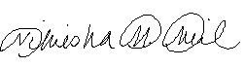
Nikiesha Neil
Exemptions Unit Manager

Enclosures

cc: Exemption File
Melissa Herndon

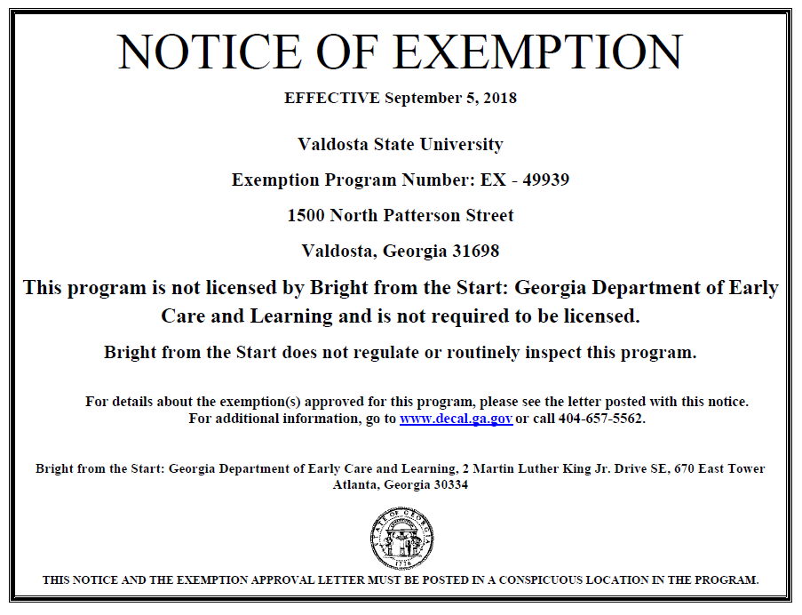

SUMMARY OF REQUIREMENTS FOR EXEMPT PROGRAMS

• Submit and maintain a valid and current e-mail address. You may activate and use your DECAL KOALA
account to do so.
• Post a copy of the Notice of Exemption certificate and approval letter indicating that the program is not licensed and is not required to be licensed by the state that includes Bright from the Start’s phone number and website address. (The Department will include the notice with approval letters).
• Obtain the signature of parent(s) or guardian(s) on a form that indicates they have been advised and understand the program is not licensed and maintain on file at your program.
• Maintain attendance records for all children.
• Maintain parental acknowledgement forms and attendance records on-site while a child is enrolled and for one year after a child is no longer enrolled.
• Make all records available to Bright from the Start upon request.
• Notify Bright from the Start in writing within five business days if your program stops operating, closes or loses accreditation.
• Comply with zoning, certificate of occupancy, fire inspection, and health department requirements.
• Submit a new Exemption Application if there are changes in the operation of the program, such as a change of ownership or a change of location. The exemption approved for your program is specific to the location address and conditions as stated on the approval letter. You should provide notice to parents/guardians of enrolled children if you do not carry liability insurance for your program. Certain types of exemptions are required to do so.
• Submit an Application for an Exemption Amendment if there are material changes in the operation of
the program, such as changes in operating months, days and/or hours, and changes in the ages served.

Bright from the Start may rescind an approved exemption under the conditions listed in Rule 591-1-1-
.46(1)(a)7.

Exemption Rules and the Exemption Application are available at
http://decal.ga.gov/ChildCareServices/Exemptions.aspx.

Questions? Send questions to CCSExemptions@decal.ga.gov or call 770/293-5977.

Bright from the Start
Georgia Department of Early Care and Learning
2 Martin Luther King Jr. Drive SE, 670 East Tower
Atlanta, Georgia 30334 www.decal.ga.gov

08/29/2018

W hat is DECAL KOALA?
DECAL KOALA is a provider self-service website available 24/7 for your convenience.

W here can I acc ess DECAL KOALA?
The website is w ww .de ca lkoa la .com .

W hat can I do on DECAL KOALA?
⇒ Update information such as your mailing address and email address
⇒ Add up to four additional secondary email addresses
⇒ Add additional information about your program
Cat eg ori es #1 (g ove rn ment -owned an d op e r at ed) a nd #7 (day c am ps) only:
⇒ Submit and check the status of records check applications online; print determination letters.

How do I get started?
You can open your account in just a few easy steps!
1. We sent you an email—Open the Welcome to DECAL KOALA email, make a note of your assigned User Name (EX-00000), and then click on the link to activate your account.
2. Create a password and enter it twice.
Now you’re ready to log in and use DECAL KOALA!
1. On the Welcome Page, enter your User Name (EX –00000) and your password.
2. Click Log In.

W here can I learn more about DECAL KOALA?
⇒ Click on Frequently Asked Questions on the bottom of the DECAL KOALA
Welcome Page ( www . de ca lkoa la .com ). You can view the Frequently Asked Questions even if you don’t have an account or are not logged in.

Have a question about exemptions?
⇒ Contact ccsexemptions@decal.ga.gov or call 770-293-5977
⇒ Go to http://www.decal.ga.gov/CCS/Exemptions.aspx

Accident/Incident Report Form

Camp Name ___________________________________________________________ Date ___________

Name of Person Involved________________________ Age ___ Sex _____ o Camper o Staff o Visitor
Last First Middle

Name of Person Involved________________________ Age ___ Sex _____ o Camper o Staff o Visitor
Last First Middle

Name of Person Involved________________________ Age ___ Sex _____ o Camper o Staff o Visitor
Last First Middle

Name of Person Involved________________________ Age ___ Sex _____ o Camper o Staff o Visitor
Last First Middle

Name of Person Involved________________________ Age ___ Sex _____ o Camper o Staff o Visitor
Last First Middle

Name/Addresses of Witnesses (You may wish to attach signed statements.)

- ____________________________________________________________________________________

- ____________________________________________________________________________________

3. ____________________________________________________________________________________

Type of Incident o Behavioral o Accident o Epidemic Illness o Other (describe)

Date of Incident/Accident _______________________________ Hour______ o a.m. o p.m.
Day of Week Month Day Year

Describe the sequence of activity in detail including what the (injured) person was doing at the time _______
______________________________________________________________________________________________________________________________________________________________________________________________________________________________________________________________________________________________________________________________________________________________________________________________________________________________________________
Where occurred? (Specify location, including location of injured and witnesses. Use diagram to locate persons/objects.)
Was injured participating in an activity at time of injury? o Yes o No If so, what activity? _________
Any equipment involved in accident? o Yes o No If so, what kind? _____________________
What could the injured have have done to prevent injury? _______________________________
_____________________________________________________________________________
Emergency procedures followed at time of incident/accident ______________________________________
______________________________________________________________________________________
______________________________________________________________________________________
By whom? _____________________________________________________________________________
Submitted by _______________________________ Position ______________________ Date __________
Phone number ______________________________

Mandatory Reporting
Valdosta State University is committed to ensuring the safety and well-being of children and the prompt reporting of suspected child abuse or neglect. These instructions outline reporting procedures for University employees and volunteers in accordance with Georgia Law (O.C.G.A. §19-7-5) and University policies for the protection of minors.

Georgia law, O.C.G.A. § 19-7-5, requires certain persons to report suspected child abuse to the appropriate authorities. Mandatory Reporters include but are not limited to faculty/teachers, administrators, counselors, social workers, psychologists, law enforcement personnel, and other persons who participate in providing care, treatment, education, training, supervision, coaching, counseling, recreational programs or shelter to minors. In addition to contacting the police department, Mandatory Reporters must also report suspected neglect or abuse to the Georgia Department of Human Services by calling 1-855-GACHILD (422-4453).

Reporting Requirements
All University employees and volunteers acting in the scope of their employment who have reasonable cause to believe that child abuse has occurred shall immediately (but no later than 24 hours) make a report to the following:

1) The VSU Police Department or 911 (emergency);
2) Their Supervisor, Program Director, or other responsible University official; AND
3) The Georgia Division of Family and Children Services (DFCS) at 1-855-GACHILD.

DO NOT attempt to investigate a matter further or gather additional information before reporting.
DO NOT rely on a third party to make a report for you.

University Follow-up
Upon receipt of a report, the VSU will investigate any suspected child abuse on campus or involving a
University employee or volunteer and will follow up with DFCS, as necessary.

University Supervisors, Program Directors, and officials will take immediate action in order to protect the minor, to encourage employee or volunteer compliance with the directives herein, and to work with the VSU during any investigation that results from the report.

Failure to Report
Failure of Mandatory Reporters, as defined by (O.C.G.A. §19-7-5), to report suspected child abuse is a violation of state law and may subject the individual to criminal penalties.

Failure of University employees or volunteers to comply with the directives herein may result in disciplinary action, up to and including termination from employment or volunteer service.

University Students
University Students employed by or volunteering on behalf of the University who have reasonable cause to believe that child abuse has occurred shall follow the Reporting Requirements listed above.

University Students at a field placement, on-site course, research project, outreach project, or other event supervised by an agency with which the University cooperates (e.g., schools, community agencies, medical facilities, internship sites) who have reasonable cause to believe that child abuse has occurred must notify the organization’s lead administrator (e.g., school principal, facility director) immediately, and subsequently notify their University Supervisor or Program Director.

Ratios: Authorized Adult to Minors
- Take into consideration of the age and activities when deciding the appropriate ratio of adult to minors
- Program Administrators are strongly encouraged to follow these guidelines and to reflect the gender distribution of the participants:
5 years and younger: 1 staff for each 6 day campers
6–8 years: 1 staff for each 6 overnight campers, and 1 staff for each 8 day campers
9–14 years: 1 staff for each 8 overnight campers, and 1 staff for each 10 day campers
15–18 years: 1 staff for each 10 overnight campers, and 1 staff for each 12 day campers
- The American Camp Association provides a good outline for ratios: https://www.acacamps.org/
- Avoid one to one contact

Youth Protection Registry:

https://apx.valdosta.edu/apex/f?p=158:LOGIN_DESKTOP:4628633155532.

IT Help with the Registry contact:
Jason Gaskins
Director of Enterprise Applications and Analytics
Information Technology Division
Valdosta State University
tjgaskin@valdosta.edu
229-333-5883
Youth Protection Exemptions:
IRB:
Exemption from training and background checks for individuals with a valid teaching certification form the State of Georgia or other state licensing agency/commission that are collecting data for IRB from their classrooms in which they would be teaching in whether or not they would be performing IRB research for a VSU Master or Ph. D level course. However, they would still need to sign the university code of conduct and be placed on the registry.
Certified Educator Course Exemption:
MOC exemption for education courses will be granted if all enrolled students in the course have been issued an educator certification by the Georgia Professional Standards Commission or another state education licensing commission for enrollment in the course or prior to interaction with minors. Educator licensing must include a background check as part of the certification process at a level that meets public school teacher requirements for the state. This exemption covers observation, field experience, student teaching/internship and research classes. This exemption does not apply to programs taking place on VSU’s campus nor courses that are taken in degree programs that do not lead to educator certification or upgrade.
In order to obtain this course/program exemption, a designee from the College of Education and Human Services is required to identify these certified educator exemption courses annually and request review by the Minors on Campus Coordinator for registration on the Minors on Campus (MOC) registry for each program/course that is requesting an exemption. The authorized adult and minor participant sections do not need to be completed for these exemption courses/programs. Each exempt participant must read and sign the VSU Youth Policy Code of conduct annually.
Office of Testing:
Exemption is granted for ACT and SAT testing.

