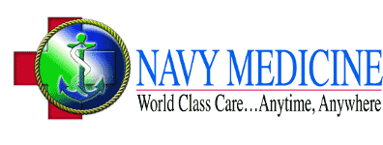

**NAVY HEALTH PROFESSIONS SCHOLARSHIP PROGRAM (HPSP)  
MEDICAL SCHOOL**

The Health Professions Scholarship Program is designed to provide a financial incentive for students in designated health care professions to complete degree requirements and obtain a commission in the Medical Corps.

**Benefits:**

• 2, 3, and 4 year scholarships available

• $20,000 signing bonus

• 100% of your tuition is paid

• Monthly stipend of approx. $2300.00 to spend as you like

• All educationally required school fees (minus housing and meals) are paid

• Full reimbursement required books, supplies, and equipment

• Active Duty pay and benefits for 45 days a year.

**Eligibility Requirements:**

• Citizenship - Must be a U.S. Citizen

• Age - Complete your degree by age 42

• Health - Must meet the Navy’s physical requirements

• Education - Must be enrolled in, or accepted for transfer into a medical school accredited by either the American Medical Association (AMA), or the American Osteopathic Association (AOA). Must have a cumulative GPA of 3.0 or above to apply. Must complete studies/training as full time students attending all normal school sessions (2 semesters or 3 quarters), and must maintain a GPA of above 3.0 after selection.

• Degree requirements must be fulfilled within 48 months

**Service Obligation:**

• Medical Corps (MC) minimum obligation is three years (four years if signing bonus is elected)

**How to Apply:**

• To apply for the Health Professions Scholarship Program, request additional information, or if you have questions, contact:

Chief Petty Officer James Barrier

2020 W Pensacola st

Tallahassee, FL 32304

904-536-6083

James.barrier@navy.mil