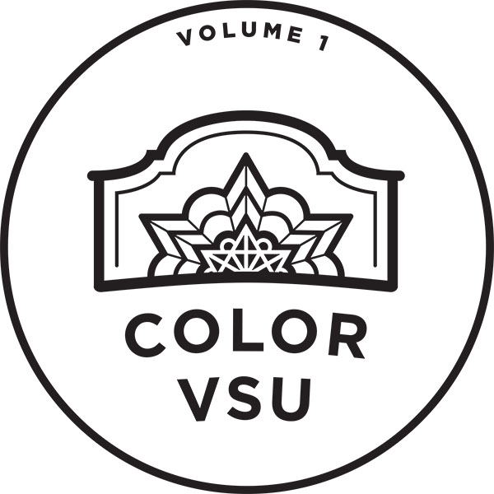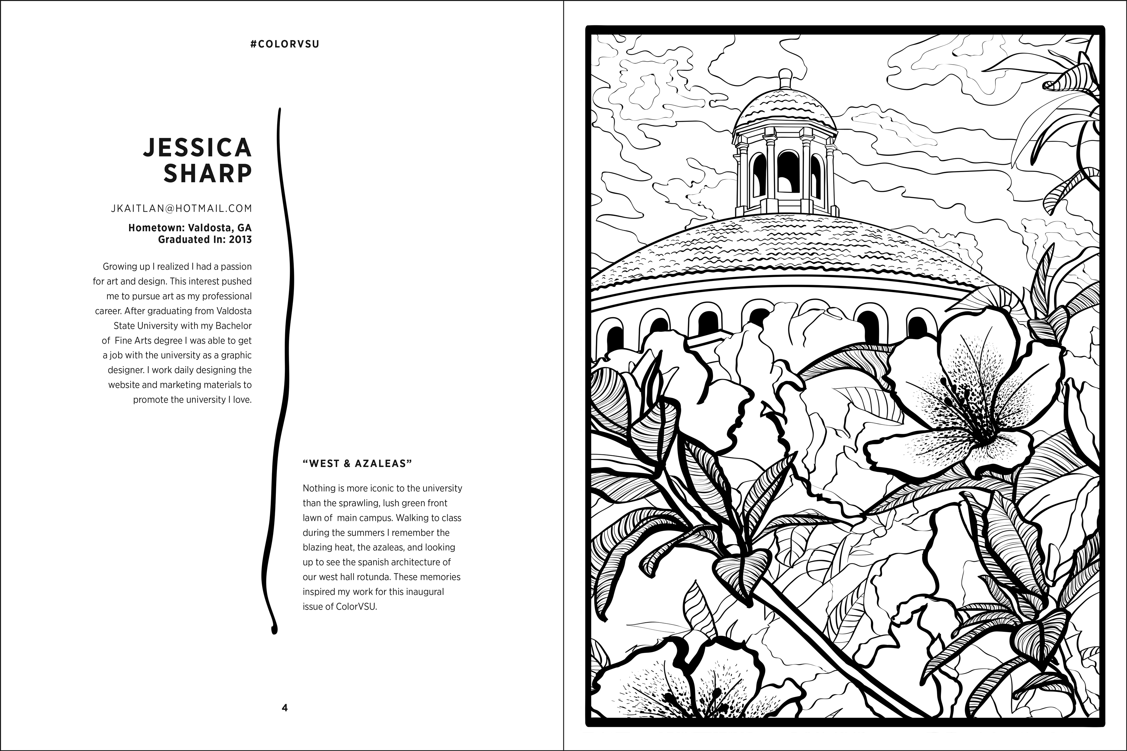

TIMELINE:
- August 31st; Contact information, Short Statement & Short Biography:
  - Contact information – Website, social media handle, email, (years attending VSU, date of graduation, etc.)
  - Short statement to include about the artwork (limit 75 words max.)
  - Short bio about you (limit 75 words max.)
- August 31st; Final artwork / digital vector image due.
- Please submit a pdf file AND a vector file if possible (Ai; Adobe Illustrator, etc.)

Email your Artwork, Contact, Short Statement & Short Biography to:
- Michael Schmidt – mschmidt@valdosta.edu
- Additional information is posted online at http://valdosta.edu/art/colorvsu.php

Contact Information:
Name:
Email:
Website:
Social Media Handle; (Facebook, Instagram etc.):
Affiliation with VSU; (Student, Alumnus, faculty, Emeritus faculty, etc.):
Timeline affiliated with VSU (Years attending/attended VSU, date of graduation, or years taught at VSU, etc.):

Art Work Information:
Title:
Short statement to include about the artwork (limit 75 words max.):

Biographical information:
Short bio about you (limit 75 words max.):

